ST. ANNE’S
COLLEGE OF ENGINEERING AND TECHNOLOGY
(Approved by AICTE, New Delhi. Affiliated to Anna University, Chennai)
(An ISO 9001 : 2015 Certified Institution)
ANGUCHETTYPALAYAM, PANRUTI – 607 110.

DEPARTMENT OF ELECTRONICS AND COMMUNICATION ENGINEERING

EC6712 OPTICAL AND MICROWAVE LABORATORY

NAME: ……………………………………………………………

REG.NO: …………………………………………………………

BATCH/YEAR: ……………………………………………………

EC6712 OPTICAL AND MICROWAVE LABORATORY
OBJECTIVES:

The student should be made to:

1. Understand the working principle of optical sources, detector, fibers and microwave components
2. Develop understanding of simple optical communication link.
3. Learn about the characteristics and measurements in optical fiber
4. Know about the behavior of microwave components.
5. Practice microwave measurement procedures

LIST OF EXPERIMENTS

OPTICAL EXPERIMENTS

1. DC Characteristics of LED and PIN Photo diode
2. Mode Characteristics of Fibers
3. Measurement of connector and bending losses
4. Fiber optic Analog and Digital Link- frequency response (analog) and eye diagram (digital)
5. Numerical Aperture determination for Fibers
6. Attenuation Measurement in Fibers

MICROWAVE EXPERIMENTS

1. Reflex klystron or Gunn diode characteristics and basic microwave parameter measurement such as VSWR, frequency, wavelength.
2. Directional Coupler Characteristics.
3. Radiation Pattern of Horn Antenna.
4. S-parameter Measurement of the following microwave components (Isolator, Circulator, E plane Tee, H Plane Tee, Magic Tee)
5. Attenuation and Power Measurement

Study of Microwave Components

Aim:
To study the various microwave components.

Components:
Rectangular waveguide:
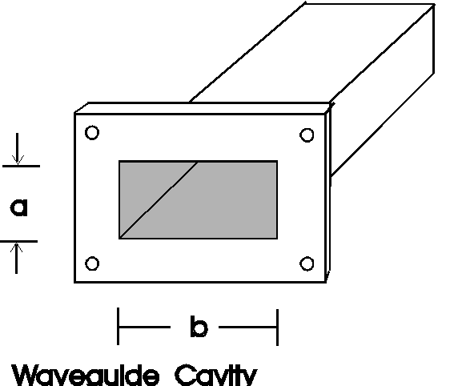

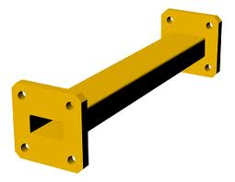

It is hollow metallic tube with a rectangular cross section. The conducting walls of the guide confines electromagnetic fields and thereby guide. A number of distinct field configurations or modes can exist in waveguides. When the wave travel longitudinally down the guide, the plane waves are reflected from wall to wall. This process results in components of either electric or magnetic field in the direction of direction of propogation of the resultant wave; therefore the wave is no longer a transverse electromagnetic (TEM) wave.

Circular waveguide:
It is a tubular, circular conductor. A plane wave propogating through circular waveguide results in transverse electric (TE) or transverse magnetic(TM) mode. Several other types of waveguides, such as ellipitical and recentrant guides.
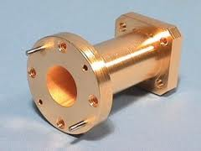

Horn antenna:
It may be regarded as flared at or opened out waveguide. A waveguide is a couple of radiating, radiation into open space provided; the same is excited at one end and opened at another end.
If the flaring is done only in one direction, then sectorial horn is produced.

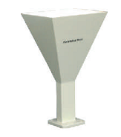
Plane Horn:
If the flaring is in position of electric vertex, the sectorial E-plane horn is obtained.

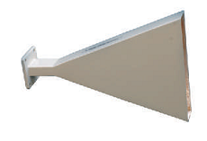

H-Plane Horn:
If the flaring is in direction of Magnetic field, the sectorial H-plane horn is obtained.
Pyramidal antenna:
If the flaring is in both the direction of electric and magnetic field, the pyramidal antenna is obtained.
Bend:
A bend is one which may be used in place where changes of direction are often required since there are discontinuities. VSWR will be increased because of different group velocity in piece of bend waveguide.
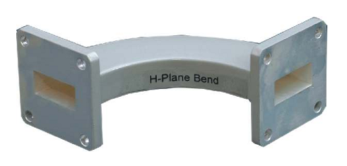
H-plane bend:
H-plane is piece of waveguide bends in plane parallel to the magnetic field for the dominant mode.
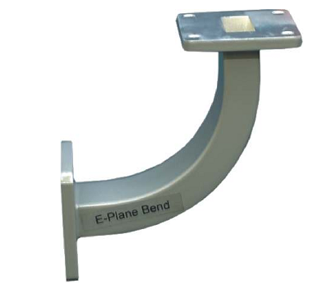
E-plane bend:
It is a piece of waveguide smoothly bends in a plane parallel to electric field for the dominant mode.
In order to keep the reflections in the bend small, its length is made several wavelengths.
90.Twist:
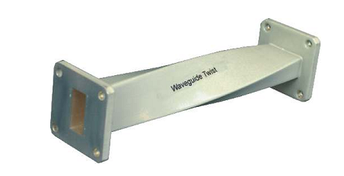
A twist is one which is used when a range of polarization directions is required. A twist may be incorporated in a bend or in a waveguide. When the angle of twist is 90.۠, it is called 90.۠ twist.

T-junction:
When it is required to combine two or more signals(or split a signal into two or more parts) in waveguide system, some part of multiple junction may be used. For simpler inter connection, T-shaped junctions are used whereas more complex junctions may be hybrid-T or hybrid rings.

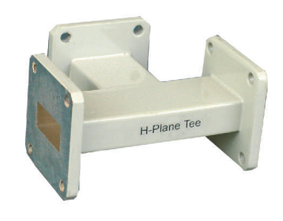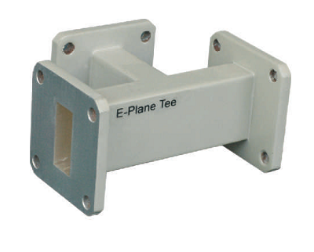

H-Plane Tee:
All three arms of H-plane Tee lies in plane of Magnetic field, which divides among the arms. This is current or parallel junctions.
E-Plane Tee:
All three arms of E-plane Tee lie in the plane of electric field, which divides among the arms. This is voltage or series junction. It may be used for impedance matching.

Magic Tee:
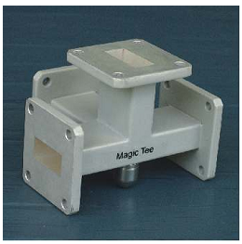
If another arm is added either to T-junction, then hybrid T-junction, is symmetrical about an imaginary plane bisecting arm3&4 and has very useful property. Magic Tee may be used in front end of the microwave receiver. The basic property in that arm3 and 4 are both connecting to arms1 and 2 but not to each other. This applies for dominant mode only, provided each arm is terminated at the correct load.
Isolator:
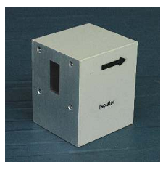
It is a two port device that allows un attenuated transmission of power in one direction, whereas power incident from other direction is completely absorbed inside isolator.
When the isolator is inserted between generator and load, the generator is coupled to the load.
Circulator:
It is a 4-port network which has peculiar property that each terminal is connected only to clockwise terminal. It is used in parametric amplifier, tunnel diode amplifiers and duplexer in RADAR.
High power circulators are similar to those of resonance isolator and handle power upto 30MW peak.
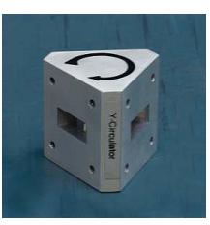

Directional Coupler:
It is a 4-port network commonly used for sampling known fraction of microwave power flowing in particular direction.
It is 4 port waveguide consisting of primary main waveguide and secondary auxillary waveguide. They can be designed to measure incident power, received power, standing wave ratio, etc.
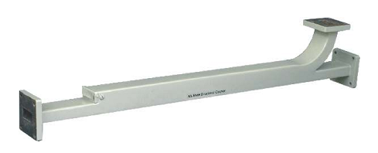

Helical antenna:
It is a broadband VHF and UHF antenna which is used when it is desired to provide circular polarization characteristics.
The antenna has loosely wound helix packed up by a ground plane is simply screen made of ‘chicken’ wire. There are two modes of radiation, normal and axial. The normal mode is one in which radiations are at right angle to axis of helix. The axial mode is one in which broadband is provided fairly directional radiation in axial direction. The helical antenna is used either singly or in array for transmission and reception of VHF signals through ionosphere.

Dish antenna:
This is also known as ‘Paraboloid’ or ‘microwave dish’. A parabola is 2D plane curve. A practical reflector is 3D plane curve surface. Therefore rotating parabola about its axis forms practical reflector. The surface so generated is known as ‘Paraboloid’ or’Parabolic reflector’.

Microstrip antenna:
In space craft or aircraft application, where size, weight, cost, performance, ease of installation and aerodynamic profile is constrains low profile antennas are required. In order to meet the specification, microstrip or patch antennas are used.
Microstrip or patch antennas are popular for low profile applications at frequencies above 10MHZ. the major disadvantage of patch or microstrip antennas.

RESULT:
Thus the various microwave components are studied.

EX.NO:1(a)
DATE:
CHARACTERISTICS OF REFLEX KLYSTRON
AIM
To study the mode characteristics of reflex characteristics and to determine the following:
1. Mode of oscillation
2. Transit time
3. Electronic tuning range (ETR)
4. Electronic tuning sensitivity (ETS)

EQUIPMENTS REQURED
Reflex klystron power supply, reflex klystron oscillator, isolator, variable attenuator, frequency meter, slotted line section with tunable probe, detector, VSWR meter/CRO

FORMULA USED
1. Mode of oscillation N =n+3/4
2. Transit time(t)=n+3/4/f₀ (sec)
Where n=integer(n=1,2,3………..)
3. 3dB electronic bandwidth=f₂-f₁(GHz)
4. ETS=f₂=f₁/v₂-v₁(MHz/volt)
5. ETR=fmax-fmin(GHz)

BLOCK DIAGRAM
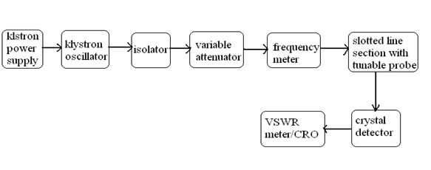TABULAR COLUMN
MODE | REPELLER VOLTAGE  (V) | O/P VOLTAGE  (mv) | FREQUENCY  (GHz)

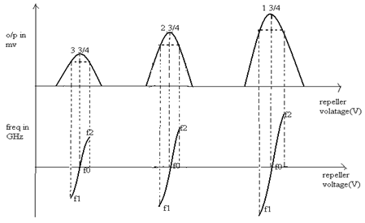

THEORY
When an electric field is applied across a gunn diode, oscillations at microwave frequencies are generated, at the voltage v, gunn GaAs diode exhibits negative resistance effect. When the gunn diode is biased, a disturbance is created at the cathode. This disturbance gives rise to a high field region which travels towards the cathode. When this high field domain reaches the anode it disappears and other domain is formed at the cathode and starts moving towards the anode and so on.
The time required for the domain to travel from cathode to anode (transit time) gives the oscillation frequency. When the diode is placed in resonant cavity, the oscillation frequency is determined by the cavity more than the diode itself.
The cavity consists of a waveguide section with movable short circuit section. It can be continually moved by tuning the knob and thus oscillation frequency is changed. Gunn diode can be amplitude modulated with the bias voltage and a separate PIN diode can also be used to obtain square wave modulation. A measure of the square wave modulation capability is the modulation depth

PROCEDURE
- Keep the control knob of klystron power supply as below
Beam knob : minimum
Mode switch : AM
Repeller voltage : maximum
AM amplitude knob: around maximum
FM frequency knob: around mid position
2. Switch ‘on’ klystron power supply and cooling fan switch
3. Switch ‘on’ the beam voltage and set the beam voltage to 300V
4. Adjust the reflex klystron voltage to get some deflection in VSWR meter
5. Maximize the deflection by tuning AM amplitude, freq control of power supply and reflector voltage.
6. Tune the frequency meter to get dip on VSWR scale and note down the frequency directly from frequency meter and then retune it.
7. Repeat the above steps for various modes and for various repeller voltage. Plot the graph between frequency and repeller voltage and between repeller voltage and the o/p voltage or o/p power.

RESULT
Thus the mode characteristics of reflex klystron are studied and the following determined.

EX.NO:1(b)
DATE:
GUNN DIODE CHARACTERISTICS
AIM

a) To study the V-I characteristics of GUNN diode.
b) Measurement of wavelength and operating frequency of Gunn diode using slotted waveguide (without frequency meter).

EQUIPMENTS REQUIRED

GUNN power supply, GUNN oscillator, PIN modulator, isolator, variable attenuator, frequency meter, slotted line section, CRO or SWR meter, wave guide stands,

THEORY

When an electric field across the GUNN diode, oscillations at microwave frequencies are been generated, at the voltage V, GUNN diode establishes negative resistance effect. When the GUNN diode is biased, a disturbance is created at the cathode. This disturbance gives rise to a high field region, which travels towards the anode. When this high field domain reaches the anode, it dis appears and the other domain is formed at the cathode and starts moving towards the anode and so on.

The time required for the domain to travel from cathode to anode gives the oscillation frequency. When the diode is placed in resonant cavity, the oscillation frequency is determined by the cavity more than the diode itself.
The cavity consists of a wave guide section with movable short circuit section. It can be continuously moved by tuning the knob and thus oscillation frequency is changed. A measure of square wave modulation capability is, the modulation depth.

PROCEDURE (a):

- Set up the test bench as shown.
- Obtain oscillations and the frequency using the general procedure.
- Increase the GUNN bias voltage in steps of 0,5V from 0V to 12V and note down the corresponding current values.
- Tabulate the readings and plot the graph of voltage Vs current.
- From the graph, note down the voltage V i.e., the minimum voltage at which the diode exhibits negative resistance.

BLOCK DIAGRAM:
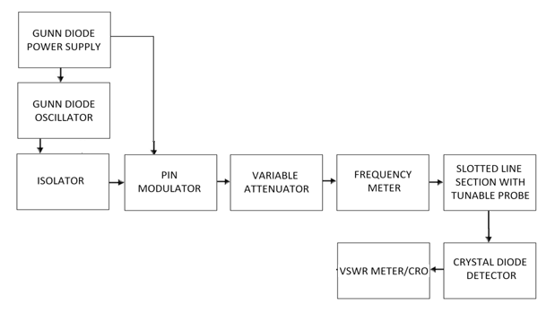
VI Characteristics:

S.No | Voltage(volts) | Current(amps)

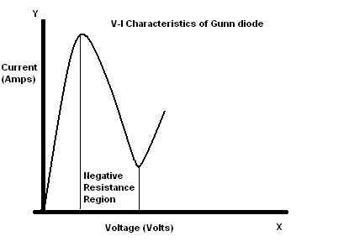
PROCEDURE (b):

- Set up the test bench as shown in the block diagram.
- Obtain oscillations and the frequency using the general procedure.
- Move the probe carriage of the slotted line section in one direction and notice minimum deflection in SWR meter.
- Note down the probe position corresponding to the minimum deflector.
- Move the probe carriage again in the same direction and follow the same procedure to obtain a number of minimum points
- The difference between two successive minima gives the value of d and 2d=λ_{g}
- Calculate λ₀ and frequency f

RESULT

The V-I characteristics of GUNN diode is studied. The minimum voltage at which the diode exhibits negative resistance is __________________V.
Frequency of oscillation ____________________________GHz.

EX.NO:1(c)
DATE:
FREQUENCY AND WAVELENGTH MEASUREMENT
aim:
To determine the frequency and wavelength in a rectangular waveguide working in TE mode.
EQUIPMENT REQUIRED:
Using Reflex Klystron:
Klystron tube, Klystron power supply, Klystron mount, Isolator, Frequency meter, Variable attenuator, Slotted section waveguide, Tunable probe, VSWR meter, Waveguide stand, Movable short/matched termination.

Using Gunn diode:
Gunn oscillator, Gunn power supply, Pin modulator, Isolator, Frequency meter, Variable attenuator, Slotted section waveguide, Tunable probe, VSWR meter, detector mount, matched termination, SS tuner, cables, cooling fan.
THEORY:
For dominant TE mode rectangular waveguide${ I}_{0}$, $I_{g}$, and $I_{c}$, are related as below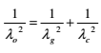
where,
$λ_{0} i$s free space wavelength
$λ_{g}$ is guide wavelength
$λ_{c}$ is cutoff wavelength For TE mode, I =2a where “a” is broad dimension of waveguide
PROCEDURE:
Using Reflex Klystron:
1. Setup the components and equipments as shown in figure.
2. Setup variable attenuator at minimum attenuation position.
3. Keep the control knobs of VSWR meter as below:
Range-50db
Input switch- crystal low impedance
Meter switch-normal position
Gain(Coarse & Fine)- Mid position

BLOCK DIAGRAM: Experimental set up for rfrequency and wavelength measurement

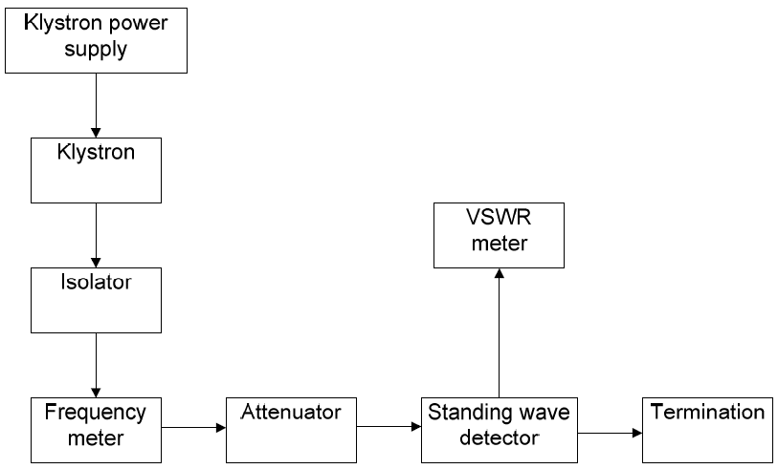

beam voltage | beam current | repeller voltage | d1  (cm) | d2  (cm) | d=d1-d2  (cm) | f○(GHZ)  using frequency meter
4. Keep the control knobs of Klystron power supply as below
Meter switch- 'OFF’
Mod-switch-AM
Beam voltage- OFF
Beam Voltage knob-Fully anticlockwise
Reflector Voltage- Fully clockwise
AM- Amplitude knob- Around fully clockwise
AM- Frequency knob – Around Mid position
5. Switch ‘ON’ the Klystron power supply, VSWR meter and cooling fan.
6. Rotate the meter switch of power supply to beam voltage position and set beam voltage at 300 V (you should not make beam voltage higher than 300V) with help of beam voltage knob (you should not touch this knob till the end of the experiment).
7. Adjust the reflector voltage to get some deflection in VSWR meter.
8. Maximize the deflection with AM amplitude and frequency control knob of power supply. 9. Tune the plunger of Klystron Mount for maximum deflection.
10. Tune the reflector voltage knob for maximum deflection.
11. Tune the probe for maximum deflection in VSWR Meter.
12. Tune the frequency meter knob to get a ‘dip’ on the VSWR scale and note down the frequency directly from frequency meter.
13. Replace the Termination with movable short, and detune the frequency meter.
14. Move the probe along the slotted line. The deflection in VSWR meter will vary. Move the probe to a minimum deflection position, to get accurate reading. If necessary increase the VSWR Meter range db switch to higher position. Note and record the probe position.
15. Move the probe to next minimum position and record the probe position again.
16. Calculate the guide wavelength as twice the distance between two successive minimum positions obtained as above.
17. Measure the waveguide inner broad dimension ‘a’ which will be around 22.86 mm for Xband.
18. Calculate the frequency by following equation
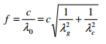
where C=3×${10}^{8}$ meter/sec (velocity of light)
19. Verify the frequency obtained by frequency meter.
20. Above experiment can be verified at different frequencies.
Using Gunn Oscillator:
1. Setup the components and equipments as shown in figure.
2. Setup variable attenuator at minimum attenuation position.
3. Keep the control knobs of the Gunn power supply as below:
Meter switch- OFF
Gunn bias knob-Fully anticlockwise
PIN bias knob- Fully clockwise
PIN mode Frequency– Any position
4. Keep the control knobs of VSWR meter as below:
Meter switch- Normal
Input switch- Low impedance
Range dB switch- 40dB
Gain control knob- Fully clockwise
5. Set the micrometer of Gunn Oscillator for required frequency of operation.
6. Switch ‘ON’ the Gunn Power Supply, VSWR Meter and Cooling fan.
A. Output power and frequency as a function of bias voltage:
1. Turn the meter switch of the Gunn power supply to voltage position.
- Increase the Gunn bias control knob.
- Rotate PIN bias knob to around maximum position.
- Tune the output in the VSWR meter through frequency control knob of modulation.
- If required then change the range dB switch of VSWR meter to high Db position to get deflection on VSWR meter. Any level can be set through variable attenuator and gain control knob of VSWR meter.
- Measure the frequency by frequency meter and detune it.
- Reduce the Gunn bias voltage in the interval of 0.5V to 10 V and note down corresponding reading of output at VSWR meter \and frequency meter.
- Use the reading to draw the power $V_{s}$ voltage and frequency $V_{s}$ voltage graph.
- Measure the pushing factor (in MHz/Volt) which is frequency sensitivity against variation in bias voltage for an oscillator. The pushing factor should be measured around 8 volt bias.
B. SQUARE WAVE MODULATION
- Keep the meter switch of GUNN power supply to volt position and rotate Gunn bias voltage slowly for maximum output not more than 10 V.
- Tune the PIN modulator bias voltage and frequency knob for maximum output on the oscilloscope.
- Chanced the bottom of square wave oscilloscope to some reference level and notedown the micrometer reading of variable attenuator.
- Now with the help of variable attenuator changed the square wave to same reference level and note down the micrometer reading.
- Connect the VSWR to detector mount and note down te dB reading in VSWR meter for both the micrometer reading of the variable attenuator.
- The difference of both dB reading in VSWR meter gives the modulation depth of PIN modulator.

RESULT:
Thus the frequency and wavelength measurement are determined.

EX.NO:1(D)
DATE:
VSWR MEASUREMENT
aim:
To determine the Voltage Standing Wave Ratio and Reflection Coefficient of a waveguide.

APPARATUS:
Klystron Power Supply, Klystron Tube, Klystron Mount, Isolator, Frequency Meter, Variable attenuator, Slotted Line, Tunable Probe, SS Tuner, Detector Mount, Wave Guide Stand, VSWR Meter, Oscilloscope, BNC Cable

THEORY:
The electromagnetic field at any point of transmission line may be considered as the sum of two traveling waves the ‘Incident Wave, which propagates from the source to the load and the reflected wave which propagates towards the generator. The reflected wave is set up by reflection of incident wave from a discontinuity in the line or from the load impedance. The superposition of the two traveling waves, give rise to a standing wave along the line. The maximum field strength is found where the waves are in phase and minimum where the two waves add in opposite phase. The distance between two successive minimum or maximum is half the guide wavelength on the line. The ratio of electrical field strength of reflected and incident wave is called reflection coefficient. The voltage standing wave ratio is defined as ratio between maximum and minimum field strength along the line. VSWR is denoted by S and is given a S=$\frac{E_{max}}{E_{min}}$ = $\frac{\left|E_{i}\right|+\left|E_{r}\right|}{\left|E_{i}\right|-\left|E_{r}\right|}$
where,
$E_{i}$= Incident Voltage
$$E_{i}=Refected Voltage$$
Reflection co.efficient ρ= $\frac{E_{r}}{E_{i}}$= $\frac{Z_{L}-Z_{0}}{Z_{L}+Z_{0}}$
where,${ Z}_{L}$= load impedance
${ Z}_{0}$= characteristics impedanceThe above equation gives the following equation
ρ = $\frac{S-1}{S+1}$
block diagram

VSWR Meter
Tunable probe

Slotted line
Isolator /Circulator
Frequency meter
Isolator
Matched Termination
Microwave source
Variable attenuator

model graph

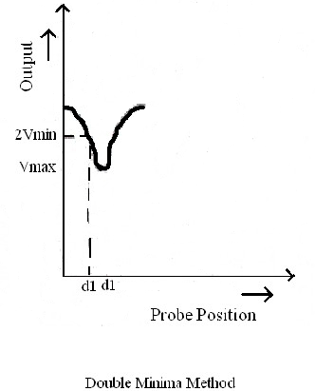
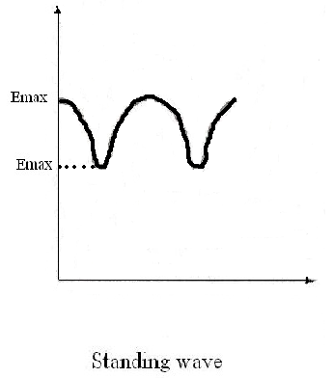
PROCEDURE:
1. Set up the components and equipments as shown in figure.
2. Keep the variable attenuator in the minimum attenuation position.
3. Keep the control knobs of VSWR meter as below
Range dB - 40 db/50db
Input Switch - Low Impedance
Meter Switch - Normal
Gain (Coarse- Fine) - Mid Position Approx.
4. Keep the control knobs of Klystron Power Supply as below
Beam Voltage - OFF
Mod- Switch - AM
Beam Voltage Knob - Fully Anticlockwise
Reflector Voltage Knob - Fully Clockwise
AM-Amplitude Knob - Around Fully Clockwise
AM- Frequency Knob - Mid position
5. Switch ON the Klystron Power Supply, VSWR meter and Cooling Fan.
6. Switch ON the Beam Voltage Switch position and set the beam voltage at 300V.
7. Rotate the reflector voltage knob to get deflection in VSWR meter.
8. Tune the output by turning the reflector voltage knob, amplitude and frequency of
AM Modulation.
9. Tune the plunger of Klystron Mount and Probe for maximum deflection in VSWR
meter.
10. If required, change the range db- switch variable attenuator position and gain
control knob to get maximum deflection in the scale of VSWR meter.
11. As you move probe along the slotted line, the deflection in VSWR meter will
change.
A. Measurement of Low and Medium VSWR
1. Move the probe along the slotted line to get maximum deflection in VSWR meter.
2. Adjust the VSWR meter gain control knob or variable attenuator until the meter
indicates 1.0 on normal VSWR meter scale.
3. Keep all the control knobs as it is, move the probe to the next minimum position.
Read the VSWR on scale.
4. Repeat the above step for change of SS Tuner probe depth and record the
corresponding VSWR.
5. If the VSWR is between 3.2 and 10, change the range db switch to next higher position and read the VSWR on second VSWR scale of 3 to 10.
B. Measurement of High VSWR(Double Minima Method)
1. Set the depth of SS Tuner slightly more for maximum VSWR.
2. Move the probe along with slotted line until a minimum is indicated.
3. Adjust the VSWR meter gain control knob and variable attenuator to obtain a
reading of 3db in the normal dB scale (0 to 10dB) of VSWR meter.
4. Move the probe to the left on the slotted line full scale deflection is obtained on 0-
10dB scale. Note and record the probe position on slotted line. Let it be d1.
5. Repeat the steps 3 and then move the probe right along the slotted line until full
scale deflection is obtained on 0-10 dB in normal dB scale. Let it be d2.
6. Replace the SS Tuner and termination by movable short.
7. Measure the distance between the successive minima positions of the probe.
Twice this distance is guide wavelength λg.
8. Compute SWR from the following equation
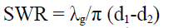
OBSERVATIONS:
Beam Voltage = VSWR= $\frac{λ_{g}}{π(d_{1}-d_{2})}$
Repeller Voltage = ρ = $\frac{S-1}{S+1}$
Low VSWR
Reading on VSWR meter =
High VSWR
Position of first minima =
Position of second minima =
Distance between two minima=
Calculations:

RESULT: Voltage standing wave ratio has been calculated by direct reading and double minima method

EX.NO:2
DATE:
CHARACTERISTICS OF DIRECTIONAL COUPLER
AIM
To measure the coupling factor and directivity of the directional coupler.
REQUIREMENTS
Klystron power supply, klystron source, isolator, variable attenuator, directional coupler, tunable detector, VSWR/CRO meter, waveguide stands.
FORMULA USED
Coupling factor
It is the ratio of power (dB) entering at the input of main arm to the power coupled at output of auxiliary arm.
Coupling factor (dB) = 10 log (Pi / Paf)
Directivity
It is the ratio of power output in coupled auxiliary arm to the power in uncoupled auxiliary arm.
Directivity (dB) = 10 log (Paf / Par)
Transmission loss
Transmission loss = 10 log (Pi / Po)
= 20 log (Vi / Vo)
THEORY
Directional coupler is a hybrid waveguide joint and a 4 port device which couples power in an auxiliary waveguide arm in one direction. A matched load by the manufacturers terminates one port. It is a device with which it is possible to measure the incident and reflected wave separately. It consist of two transmission lines the main arm and the auxiliary arm, electromagnetically coupled to each other. The power entering port1 in main arm divides between port2 and port3 and almost no power comes out in port4. Power entering port2 is
divided between port1 and port4. Main line insertion loss is the attenuation introduced to transmission line by insertion of coupler. It is defined as insertion.
Loss = 10 log (P1 / P2)
when power is entering at port1.

BLOCK DIAGRAM

Isolator
Pin
Modulator
Gunn
Oscillator
Gunn
Power
Supply
Variable
Attenuator
Frequency
Meter
Slotted line section with tunable probe
Directional
Coupler
Crystal
diode
detector
VSWR/
CRO
Matched
Termination

PROCEDURE
- Set up the equipments as shown in block diagram.
- Obtain the oscillations using the general procedure and determine the frequency of oscillation.
- Set the reference voltage in CRO with the help of variable attenuator and gunn power supply.
- Connect directional coupler in forward direction between slotted line section and detector mount keeping input port P1 to slotted line section, output port P2 to detector mount and P4 is terminated (P3 is permanently matched). Measure the output voltage V0 at port2.
- Similarly keeping P1 to slotted line section, P4 to detector mount and port2 is terminated. Measure the voltage P_{af}at P4.
- Keeping P2 to slotted line section. P4 to detector mount and P1 is terminated. Measure the voltage P_{ar} at P4.
- Calculate coupling factor, directivity and transmission loss (dB) using Pi, Po, Paf, Par.
 | P1  (V) | P2  (V) | P3  (V) | P4  (V)
TABULATION

RESULT: Thus the characteristics of directional coupler were studied and the directivity and coupling factor were determined.

EX.NO:3
DATE:
RADIATION PATTERN OF HORN ANTENNA
AIM:
To measure the radiation pattern of horn antenna and to draw its field pattern.
EQUIPMENTS REQUIRED:
Klystron power supply, klystron oscillator, isolator, variable attenuator, frequency meter, horn antenna and VSWR/CRO.
THEORY:
Gain of an antenna:
It is the power intensity at the maximum achieved from imaginary omni-directional antenna with same power fed to antenna.
Antenna gain can be measured by using two identical antennas, one as transmitter and the other as receiver. But should be kept away from each other with minimum distance R.
Rmin = 2D^2/λ0 [for rectangular horn antenna]
D – Size of broad wall of horn antenna
λ0 – Free space wavelength
Gain of transmitting antenna is,
G = (4Π Rmin/ λ0) * (Pr/ Pb)
Field pattern:
It is the diagram of field strength or power density as the function of transmitter at constant distance from radiating antenna.
As antenna pattern is 3D but it is given as 2D pattern on paper. For rectangular horn antenna there are E and H plane pattern. The major power is concentrated in main lobe and is desirable to keep the power load and back lobe as low as possible.
PROCEDURE:
- Set up the equipment as shown.
- Obtain oscillation using general procedure and determine frequency of oscillation.
- Set the reference voltage in CRO using variable attenuator, power supply and tuners.
- Remove the detector mount from slotted line section without disturbing the position of the set up.
- Connect transmitting and receiving horn antenna between slotted line section and detector mount.

BLOCK DIAGRAM:
Klystron
Power
Supply
Klystron
Oscillator

Isolator

Variable attenuator

Frequency
Meter
VSWR/
CRO
Crystal
Detector
Rotatory
Joints
Slotted line section with tunable probe
TABULATION:
ROTATING  RECEIVER  (degrees) | RECEIVED VOLTAGE (V)
 | LEFT SIDE (mV) | RIGHT SIDE (mV)

- Rotate the receiving horn to left in steps of 5˚ and note the corresponding voltages.
- Rotate the receiving horn to right as in step6.
- Tabulate the reading and draw the graph for transmitting and receiving voltages.

RESULT: Thus the gain and field pattern of horn antenna were obtained
. Ex.NO:4
DATE:
S-PARAMETER MEASUREMENT
AIM:
- To measure the insertion loss and isolation loss of a given isolator and circulator.
- To study the characteristics of E-plane tee, H-plane tee and magic tee
EQUIPMENT REQUIRED:
Isolator and Circulator:
Gunn power supply, Gunn oscillator, Pin modulator, Isolator, Variable attenuator, Frequency meter, Slotted line section with tuneable probe, Diode detector, Circulator, VSWR meter/ CRO, Waveguide stands
E-plane tee, H-plane tee and magic tee:
Microwave source, Isolator, variable attenuator, frequency meter,E-plane Tee, H-plane Tee,magic tee, Matched terminator, detector mount, slotted line section with tunable probe,VSWR/CRO.
THEORY:
ISOLATOR:
The isolator is a two port device with small insertion loss n forward direction and a change in reverse attenuation.
CIRCULATOR:
The circulator is a multiport junction that permits transmission in certain ways. A wave incident in port 1 is coupled to port 2 only, an incident wave at port 2 is coupled to port 3 only and so on. Following is the basic parameters of isolator and circulator for study.
E-plane Tee:
In E-plane Tee, the auxiliary arm is parallel to the plane of electric field. E-arm is input arm. Input power is equally distributed between arms 1 and 2. But the output at arm1 is 180® out of phase. So, E-plane is also called ‘subtractor’.
H-Plane Tee:
In the H-plane Tee, auxiliary arm is parallel to plane of magnetic field. If the input is applied for H-plane, power gets divided equally between arm1 and 2 and power at same phase. So H-plane is also called ‘adder’.

Magic tee:
Magic tee is a combination of E and H plane Tee. Arm 3, the H-arm forms H-plane tee. Arm 4, E-arm forms E-plane tee, in combination of arm 1 and arm 2 as side or collinear arms. If the power is fed to arm 3(H-plane), electric field divided equally between arm 1 and 2 with same phase. If the power is fed to arm 4(E-plane), the electric field is divided equally between arm 1 and 2 with opposite phase. Further if the power is fed from arm 1 and 2, it is added in arm 3(H-plane) and is subtracted in arm 4(E-plane).
INSERTION LOSS:
The ratio of power supplied to the input port to the power detected by the detector in the coupling arm.
ISOLATION LOSS:
It is the ratio of power fed to input arm and the power detected at no coupled port with the other port terminated in the matched load.
INPUT VSWR:
The input VSWR of an isolator or circulator is the ratio of voltage maximum to voltage minimum of the standing wave existing on the line, when one port of it terminates the line, and the other have matched termination.
When port which is not coupled to input port is terminated by matched termination in a circulator, then it makes an isolator (2 ports device)

BLOCK DIAGRAM:
ISOLATOR :
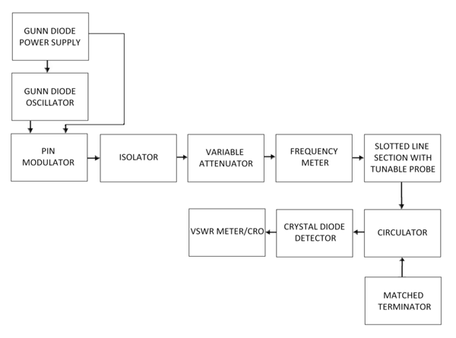

ISOLATOR :
Reference voltage : ________
Input  Port | Output  Port | Output voltage  (mV) | Insertion loss  20*log(V1/V2) (dB) | Isolation loss  20*log(V2/V1) (dB)
P1  P2 | P2  P1

E-PLANE TEE
KYLSTRON OSCILATOR
KYLSTRON POWER SUPPLY
VSWR/CRO
DETECTOR
SLOTTED LINE SECTION WITH TUNABLE PROBE
FREQUENCY METER
VARIABLE ATTENUATOR
MATCHED TERMINATION
E-PLANE TEE
ISOLATOR
E-PLANE TEE
P1 | P2 | P3 | ATTENUATION IN dB | COUPLING COEFFICIENT C

H-PLANE TEE
KYLSTRON OSCILATOR
KYLSTRON POWER SUPPLY
VSWR/CRO
DETECTOR
SLOTTED LINE SECTION WITH TUNABLE PROBE
FREQUENCY METER
VARIABLE ATTENUATOR
MATCHED TERMINATION
H-PLANE TEE
ISOLATOR

H-PLANE TEE
P1 | P2 | P3 | ATTENUATION IN dB | COUPLING COEFFICIENT C

MAGIC TEE:
KYLSTRON OSCILATOR
KYLSTRON POWER SUPPLY
VSWR/CRO
DETECTOR
SLOTTED LINE SECTION WITH TUNABLE PROBE
FREQUENCY METER
VARIABLE ATTENUATOR
MATCHED TERMINATION
MAGIC TEE
ISOLATOR
P1 | P2 | P3 | P4 | ATTENUATION IN dB | COUPLING COEFFICIENT C
FORMULAE USED:
INSERTION LOS:
It is the ratio of power (dB) supplied by a matched source to arm 1 to the power detected by matched detector in coupling arm 2.
Insertion loss = 10 log (P1/P2) (dB)
= 20 log (V1/V2) (dB)

ISOLATION LOSS:
It is the ratio of power fed to arm 2 by a matched source to the power detected in arm 1 by matched detector.
Isolation loss = 10 log (P2/P1) (dB)
= 20 log (V2/V1) (dB)
PROCEDURE :
ISOLATOR :
1. Set up the equipment as shown in block diagram.
2. Obtain oscillations using general procedure and determine frequency of oscillation.
3. Set the reference voltage in CRO with variable attenuator and Gunn diode power supply.
4. Connect isolator in forward direction between slotted line section and detector mount keeping input port P1 to slotted line section and output P2 to detector mount.
5. Measure to output voltage at port 2 and calculate insertion loss (dB).
6. Measure the isolation loss, connect isolator in reverse direction and measure output voltage at P1.
E-PLANE TEE and H-PANE TEE:
1. Set up the circuit as shown in the block diagram.
2. Obtain the frequency of oscillation using general procedure.
3. Set any reference value of power in CRO with the help of variable attenuator and Gunn power supply.
4. Connect E-plane and H-plane between slotted line section and detector mount.
5. Port 3 is always input port. Connect port2 to slotted line section and port 1 to detector mount . 6. Similarly connect port 1 to slotted line and port 2 to detector mount.
7. Step 5 is done for E and H plane Tee. In both junctions, port 3 junctions are impedance.
MAGIC TEE:
1. Set up the circuit as shown in the block diagram.
2. Obtain the oscillation using general procedure and determine the frequency of oscillation.
3. Set the reference voltage in the CRO (P_{i}) with the help of variable attenuator and gunn power supply.
4.Connect magic tee between slotted line section and detector mount with any two ports terminated, one of the port is connected to slotted line section and other port is connected to detector mount.
5. Measure the output voltage.
6. Repeat step 4 by interchanging ports for all other 12 combinations.
7. Measure input and output voltage for 12 sets and are tabulated. Using tabulated values scalculate isolation between ports and coupling coefficient.

RESULT :
Thus the insertion loss and isolation loss for given circulator and isolator were measured and charactertics of E-plane and H-plane tee, magic tee.

Ex.NO: 5
DATE:
ATTENUATION AND POWER MEASUREMENT

AIM:
To measure the attenuation and power in microwave device.
APPARATUS REQUIRED:
Attenuator, isolator, microwave source, variable attenuator, frequency meter, slotted line section, tunable probe, detector mount, power meter, CRO, cables and accessories
THEORY:
Attenuator is a 2 port bidirectional device which attenuator power when inserted into the transmission line. It radiates in many directions. The attenuators are basically passive devices which control power levels in microwave system by absorption of the signal. Attenuator which attenuates the RF signal in a waveguide system is referred as waveguide attenuator. There are two main types fixed and variable. They are achieved by insertion of resistive films.
PROCEDURE:
- Set up the experiment as shown in figure.
- Note the input voltage by using the microwave source
- Connect the power measurement device and note down the power value.
- Similarly note the power in reverse direction
- Then calculate the power and attenuation

TABULATION:

Power 1 | Power 2 | Power 3

RESULT:
Thus attenuator and power was measured using the microwave device

EX.NO:1

DATE:

DC CHARACTERISTICS OF LED AND PIN DIODE
AIM:

- To determine the DC characteristics of LED and PIN diode.

- To study the zero bias, forward bias and reverse bias characteristics of PIN photo diode and plot the VI and PI characteristics

EQUIPMENTS REQUIRED:

LED:OFT power supply, digital multimeter, LED module, benchmark fiber optic power meter, bare fiber adaptor, ST adaptor for meter, 1.25m plastic fiber, 1m ST-ST patch cord
PIN photo diode:OFT powers supply, PD module, Optical power meter,Optical power source,Bare Fiber adapter-Plastic,1m patch cord,1MΩ,10KΩ resistors,Digital multimeter
THEORY:
LED:
LED is the vital part in a fiber optic communication link. It forms the E-O section of the transmitter in any link. In LED module the injection current through an 850nm / 1300nm fiber optic LED (depending on the model) is varied and thereby its characteristics are studied. The injection current through the LED is controlled using a multi-turn potentiometer, which enables the user to have a control over it. The LED module “1300nm GF-MM” is shown. The module needs an external DC power supply to operate. The LED module is provided with appropriate monitoring posts for taking the necessary measurements.
PIN photo diode:
If a photon having adequate energy [should be greater than the band gap] is absorbed by a p-n junction, an electron will be transferred to the conduction band, thereby forming a hole in the valence band. As a result, an open circuit voltage is created and a current will flow, provided the circuit is closed through a load resistor. In case of reverse bias p-n junction, the transit time can be made small and it will produce current linearly proportional to the incident photon energy.

The frequency response can be improved if the p-n junction is separated by an intrinsic region. The introduction of the intrinsic region decreases the junction capacitance. This is called ‘Positive Intrinsic Negative’[PIN] photo diode. For high frequency operation, the PIN diode can be made as small as practical, to match the size of the spot of the optical beam.
PROCEDURE:
LED:
- Connect the OFT power supply to the module. Turn the multi-turn potentiometer to its minimum position and switch ON the module.

  - Measure the voltage V1 across the resistor R1 (1800ohms for 850nm PF) and calculate the current through the LED If which is given as

If = V1 / 180 for 850nm PF

  - Measure the voltage VLED across the LED and note down

  - Remove the dummy adaptor cap from the power meter PD. Mount the bare fiber adaptor

– plastic over the PD.

  - Now without changing any voltage or the potentiometer, measure the optical power output P of the LED.
PIN photo diode:
- Zero bias:
  - Make the set-up as in the diagram and connect the 1MΩ resistor across .
  - Set the power source in CW mode and adjust to get maximum output. Connect the 1m ST-ST patch cord between source and power meter and adjust the power to -18 dBm.
  - Connect the optical fiber cable to the PD module and measure the voltage across _{L} [1MΩ] and note as .
  - Vary the optical power input in steps of 2 to 3 dBms.
  - Tabulate the readings and calculate =/ (1 x 106).
  - Calculate power in microwatts from the formula :
  - Draw the graph :Power[in Watts] Vs .
- Forward bias:

  - Connect the 10 KΩ resistor across .
  - Adjust the potentiometer and set the bias voltage at 10 V.

- Set the power source in CW mode and adjust to get maximum output. Connect the 1m ST-ST patch cord between source and power meter and adjust the power to -18 dBm.
- Connect the optical fiber cable to the PD module and measure the voltage across _{L} [10 KΩ] and note as .
- Vary the optical power in steps of 2 to 3 dBm and note down the corresponding.
- Calculate _{F}=/ (1 x 104).
- Plot the graph : Power in Watts Vs IF.
- Now, fix the optical power at some constant value say -10 dBm and vary the VBIAS from 1V to 10 V in steps of 1 V and note down the corresponding
- Plot _{BIAS}Vs _{F}.
Reverse bias:
- Connect the 10 KΩ resistor across .
- Adjust the potentiometer and set the bias voltage at 10 V.
- Set the power source in CW mode and adjust to get maximum output. Connect the 1m ST-ST patch cord between source and power meter and adjust the power to -18 dBm.
- Connect the optical fiber cable to the PD module and measure the voltage across _{L} [10 KΩ] and note as .
- Vary the optical power in steps of 2 to 3 dBm and note down the corresponding .
- Calculate _{R}=/ (1 x 104).
- Plot the graph : Power in Watts Vs _{R}.
- Now, fix the optical power at some constant value say -10 dBm and vary the _{BIAS} from 1V to 1 V in steps of 1 V and note down the corresponding .
- Plot _{BIAS} Vs _{F}.
- Calculate the responsivity from :
_{λ} = /( _{L}* _{S}) A/W where _{S}is the power in Watts.
11. From the average value of _{λ}, calculate the quantum efficiency using :
ηC = ( _{λ}hν/e) x 1/100 %
where h=6.64 x 10-34 Js; e = 1.6 x 10-19 C; ν = c/λ = 3 x 108 /λ

1.LED
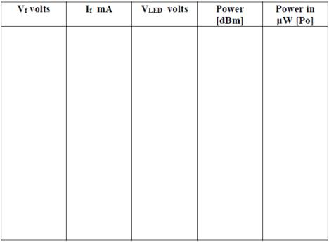
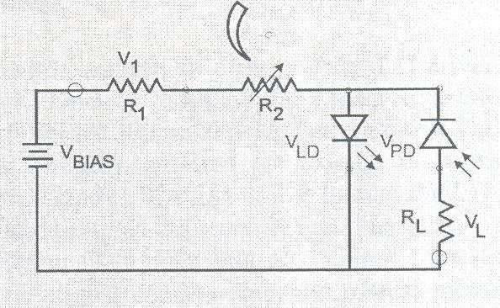
LED MO

MODEL GRAPH

2. PIN Photo Diode:

RESULT:

Thus the characteristics of LED was studied
EX.NO:2

DATE:
MODE CHARACTERISTICS OF SINGLE MODE FIBERS
Aim:
To Study the Mode Characteristics of Single Mode Fibers.
Components Required:
Single mode fiber, He-Ne laser, power meter, fiber coupler, fiber cleaver, 20x objective lens, rotation stage, micro series holder, micro series poster, fiber positioner, methylene chloride
Theory:
The propagation characteristics of a single mode fiber can be obtained by solving Maxwell’s equation for the cylindrical fiber waveguide. This leads to the knowledge of the allowed modes which may propagate in the fiber .When the number of the allowed modes is very large, the mathematics becomes very complex; this is when the ray picture is used to describe the waveguide properties.
The V-number of the fiber is given by:
V= .a.NA
Where,
- the free – space wavenumber ,2ᴨ/ ₀ (/ ₀ is the wavelength of the light in free space) a - the radius of the core
NA- the numerical aperture of the fiber .
The V –number can be used to characterize which guided modes are allowed to propagate in a particular waveguide structure.When V < 2.405, only a single mode ,the HE11 mode,may propagate in the waveguide.This is the single mode regime.The wavelength at which Vis
equal to 2.405 is called the “cut-off wavelength”,(denoted by ) because that is the wavelength at which the next higher order mode is cut off and no longer propagate

BLOCK DIAGRAM

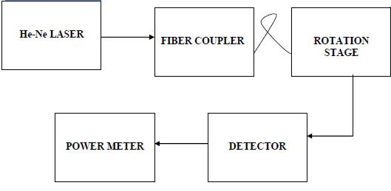

MODEL GRAPH:

Field Distribution:
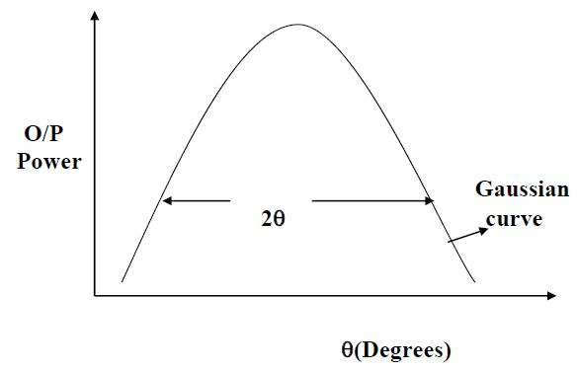

TABULATION

RESULT:

Thus the mode characteristics of the single mode fibers were studied

EX.NO:3
DATE:
MEASUREMENT OF CONNECTOR AND BENDING LOSS
AIM:
To establish a fiber optic analog link using a connector and determine the coupling loss

To determine the bending loss of the fiber
COMPONENTS REQUIRED:
OFT Kit, CRO, Function Generator, 1m and 3m OF cables, Jig for connecting 2 fibers
THEORY:
Optic fibre are available in different variety of materials. There materials are usually selected by taking into account their absorption characteristics for different wavelength of light since the signal is transmitted in the form of light one has to consider interaction of matter to study loss in fibre .
Whenever condition for angle of incidence is violated the losses are introduced due to refraction of light. this occurs their fibre is subjected to bending lower the radius more is the loss. Another losses are due to coupling of fibre at led and photo detector.
Losses are introduced in fibre due to various reasons. As light propagate from one end to another part of it is absorbed in the material exhibiting absorption loss. Also part of light is reflected back.
PROCEDURE:
Make the connections as in the diagram. Connect the input signal from FG to I/O-1. Short I/O-1,I/O-2 and P11 ________. Connect I/O-2 and the output from P31 to the two channels of CRO. Set the switch SW8 to analog position. Adjust the gain control knob to obtain proper shape of the output signal.

To measure the Bending loss in the fiber :

- Connect the 1m fiber between the Tx and Rx.

- Note down the output voltage as Voutbb.

- Take the 10mm radius mandrel and make 1 or 2 turns of the fiber on the mandrel and note down the output as Voutab.

- Now replace the 10mm mandrel with 12mm mandrel and note down the output voltage.

- Repeat step 1 for 3m cable.

- Calculate the bending loss from the formula: Bending Loss[dB]= 20*log[Voutbb/Voutab]
BLOCK DIAGRAM:

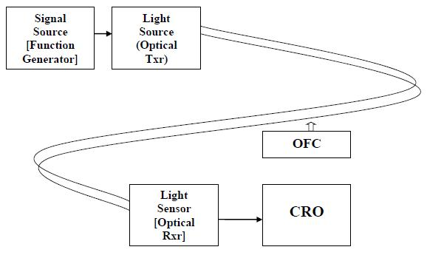

TABULATION:
For Bending Loss:

bending diameter | output voltage

For coupling Loss:

cable | input amplitude(v) | output amplitude(v)

- To measure the Coupling loss in the fiber :

  - Connect one end of the 1m fiber to the Tx and one end of the 3m fiber to the Rx.

  - Connect the remaining 2 end together using the Jig making the ends to touch each other.

  - Note down the input and output voltages.

  - With the same input voltage, introduce 1cm gap between the fiber ends connected in the jig and note down the output voltage.

  - Calculate the coupling losses without gap and with 1cm gap using the formula:

η= 20*log [Vin / Vout] – α’[L1+L2] where α’= 4.343α and L1= 1m and L2= 3m

RESULT:

The fiber optic link for analog transmission has been set up and the following were determined

EX.NO:4(a)
DATE:
FIBER OPTIC ANALOG LINK
AIM:
To study a fiber optic analog link and to obtain the relationship between the input signal and the received signal.
PROCEDURE
  - Connect the power supply to the board.
  - Ensure that all switch faults are OFF.
  - Make the following connections.

  - Connect the function generator 1 KHz sine wave output to the emitter 1’s input.

  - Connect the fiber optic cable between the emitter’s output and detector’s input.

  - Connect detector’s output to the AC amplifier 1’s input.
  - On the board switch emitter 1’s driver to analog mode.
  - Switch ON the power.
  - Observe the input to emitter (tp 5) with output from AC amplifier 1 (tp 28) and note that the two signals are same.
THEORY:
The Fiber Optic Analog Link consists of a transmitter which converts an electrical signal to a light signal, an optical fiber to guide the light and a receiver which detects the light signal and converts it to an electrical signal. Light sources are either light emitting diodes (LED's) or laser diodes and detectors are phototransistors or Photodiodes
The transmission medium in fiber-optic communications systems is an optical fiber. The optical fiber is the transparent flexible filament that guides light from a transmitter to a receiver. The key component of an optical receiver is its photo detector. The major function of a photo detector is to convert an optical information signal back into an electrical signal (Photocurrent). The photo detector in today's fiber - optic communications systems is a semiconductor photodiode (PD). This miniature device is usually fabricated together with its electrical circuitry to from an integrated package that provides power-supply connections and signal amplification.

BLOCK DIAGRAM: SETTING UP FIBER OPTIC ANALOG LINK

Emitter circuit Detector circuit
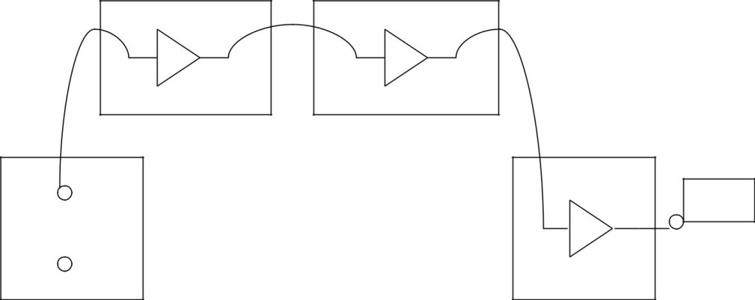

TABULATION:

Input Voltage | Output Voltage | Time
(V) | (V) | (ms)

RESULT:

Thus the relationship between input and output waves was obtained using the fiber optic analog link

EX.NO:4(b)
DATE:
FIBER OPTIC DIGITAL LINK
AIM:
To study a fiber optic digital link and to obtain the relationship between the input signal and the received signal.
PROCEDURE:
- Connect the power supply to the board.

- Ensure that all switch faults are OFF.

- Make the following connections.

- Connect the function generator 1 KHz square wave output to the emitter 1’s input.

- Connect the fiber optic cable between the emitter’s output and detector’s input.

- Connect detector 1’s output to the comparator 1’s input.

- Connect comparator 1’s output to AC amplifier 1’s input.

- On the board switch emitter 1’s driver to digital mode.

- Switch ON the power.

- Monitor both the inputs to comparator 1 (tp 13 and tp 14). Slowly adjust the comparator bias. Reset until DC level on the input (tp 13) lies midway between the high and low level of the signal on positive input (tp 14).

- Observe the input to emitter (tp 5) with output from AC amplifier 1 (tp 28) and note that the two signals are same.

BLOCK DIAGRAM: SETTING UP FIBER OPTIC DIGITAL LINK

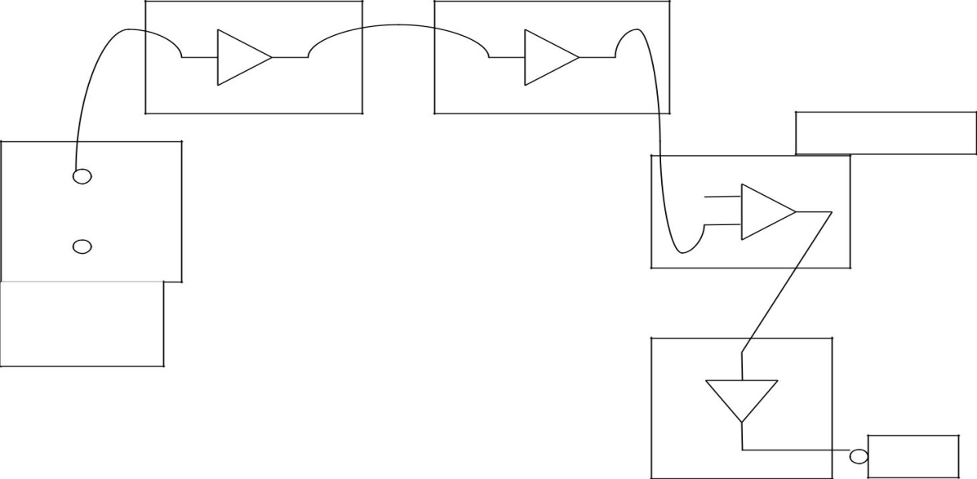

TABULATION:

Input Voltage | Output Voltage | Time
(V) | (V) | (ms)

RESULT:
Thus the relationship between input and output waves was obtained.

Frequency (KHz)
EX.NO:4(c)
DATE:
EYE DIAGRAM
AIM:
To compare the effect of EMI/RFI on a copper medium and an optical fiber medium.
EQUIPMENT REQUIRED:
OFT, Two channel oscilloscope 20MHz, Function generator 1 Hz – 10 Hz, EMI unit, Patch cord [supplied with OFT] 40 cm
THEORY:
While optical fiber has established itself as the medium for long-haul wide-bandwidth communications, it has also made a significant impact in other application where neither the link nor the bandwidth requirement is large. This is because optical fiber is a dielectric medium, i.e. totally non-metallic. The signal propagating is optical and does not have any associated voltage or current. In many environment today, Electromagnetic Interference [EMI] and Radio Frequency Interference [RFI] have become a serious problem affecting even low bit-rate communication over short distances. Optical fiber, being totally dielectric, has immunity to EMI/RFI and is finding widespread application in such situation.
PROCEDURE:
- Set up the digital link using optical fiber.

- Remove the shorting plugs of shorting links S6 in the Manchester coder block and S26 in the decoder & clock recovery block.

- Reconnect the shorting plug at S6 and S26. Remove the fiber. Connect P12 in the electrical o/p block and P32 in optical Rx1 block using the 40cm patch cord supplied with OFT. Adjust GAIN to ensure that the multiplexer / demultiplexer is working. The shorting of P12and P32 establishes an analog link between the Tx and the Rx side on copper cable.

- Using the signal at S7 as the external trigger for the oscilloscope, observe the signal at P31. The Rx data observed at the oscilloscope now starts with the digitized voice data in slot1. Increase the time scale to observe only on roe two bits on the scope.

Disconnect the patch cord at P12, insert it through the coil tube in the EMI unit supplied for interference generation, and reconnect it at P12 with the coil now around the wire. Connect the interference coil to a function generator and excite it

EYE DIAGRAM:

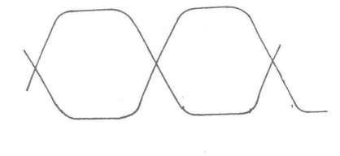

EYE DIAGRAM IN THE PRESENCE OF INTERFERENCE
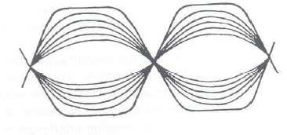

EMI COIL UNIT:
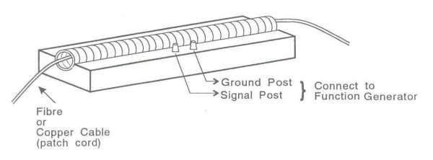

- with a sinusoidal signal of around 100 KHz at around 5V p-p, with zero D.C. Observe the signal P31.
- Repeat steps 6 and 7 for several frequencies between 500 KHz and 1 MHz and note the voltages required for the interference to affect the working of the multiplexer.
- Remove the patch cord containing P12 and P32. Put the interfering coil around a 1m optical fiber and set up the optical link at 850 nm.

RESULT:

Thus the effect of EMI/RFI on a copper medium and an optical fiber medium.

EX.NO:5
DATE:
NUMERICAL APERATURE DETERMINATION FOR FIBERS
AIM:
To establish a fiber optic data link and determine the numerical aperture of the fiber
EQUIPMENT REQUIRED:
OFT Kit, CRO, Function Generator, Patch cords, Optical fibre cable[1m,3m], Jig for numerical aperture measurement
THEORY:
Large bandwidth, low attenuation are the important characteristics of optical fibers which makes them suitable for long distance communication, more particularly data communication. Fiber systems for rates below 10 Kbps are cheap and can be readily constructed from basic components. Data rates from 100 Kbps to 10 Mbps are costly and difficult to implement. However, with advancement in technology data rates more than 10 Mbps are also possible.
PROCEDURE:
- Insert one end of the fiber into the numerical aperture measurement

- Gently tighten the screw to hold the fiber firmly in place.

- Connect the other end of the fiber to LED2. The fiber will project a circular patch of the light on the screen. Let‘d’ be the distance between the fiber tip and the screen. Now measure the diameter of circular patch of red light in perpendicular directions
- The mean radius of the circular patch is calculated from:

    - X = [DE + BC] /4 s
- Calculate NA from: NA = sinθ = X /√[d2+X2]

- Repeat the above steps for different values of‘d’.

- Tabulate the readings and find the average value of NA.

BLOCK DIAGRAM FOR NUMERICAL APERTURE:

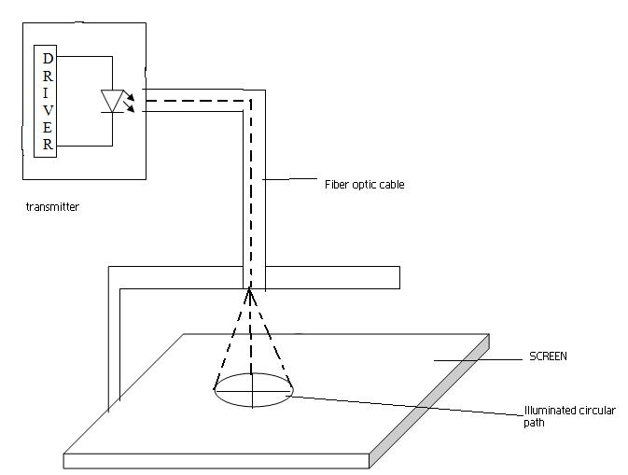

TABULATION:

DISTANCE | HORIZONTAL | VERTICAL | R = Bn + | NA= | Өa=sin⁻¹(NA)
(cm) | DISTANCE | DISTANCE | An / 4 | R/(d²+R²)^{1/2} | degrees
 |  | (cm)
 | (cm)

RESULT:

The fiber optic link for data transmission has been set up and numerical aperture is calculate

EX.NO:6

DATE:
ATTENUATION MEASUREMENT IN FIBRES
AIM:
To measure attenuation loss in fiber optic communication link
EQUIPMENTS REQUIRED:
OFT, two channel oscilloscope 20MHz, Function generator 1 Hz – 10 Hz, Fiber alignment, BNC Cables
THEORY:
The fiber used in OFT is multimode plastic fiber with 1000 μm core diameter. Unlike its Glass-Glass Plastic Coated Silica fiber counterparts, this fiber has very high attenuation. It is useful mainly for short links such as in Local Area Network, especially where there could be serious EMI problems. This fiber has been selected for the OFT because of the ease of handling it affords. While the loss in plastic fiber is high for all wavelength regions, the loss at 850 nm is such higher than at 650 nm. Apart from the above propagation loss in a fiber, bending of fiber, connectors, splices and couplers may all contribute significantly to the losses in a fiber optic communication link. An optical fiber is a circular wave guide. A small in a fiber will not significantly affect the propagation characteristics and therefore the losses in the fiber. However, if the fiber is bent with a radius of curvature smaller than a certain value (usually about a centimeter), the propagating signal may suffer significant bending loss. Two optical fibers are joined using either a connector or a splice. The alignment of the cores of two fibers is critical in both the situations, as even the minutest misalignment or gap between the fibers may cause significant coupling losses.
PROCEDURE:

- Connect the power supply cables with proper polarity to optical transmitter and receiver kit while connecting this ensure that power supply is off.

- Switch on the power supply feed about 2 vpp sinusoidal signal of 1 KHZ from the function generate to analog in of the optical transmitter kit.

- Insert 1m fibre cable into cap of SFH 756 v ( 660 nm ). Connect the other end of fibre to detector SFH 250 v ( photo transistor detector )

BLOCK DIAGRAM:

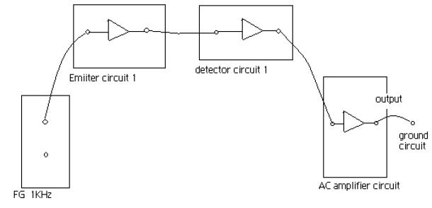

TABULATION:

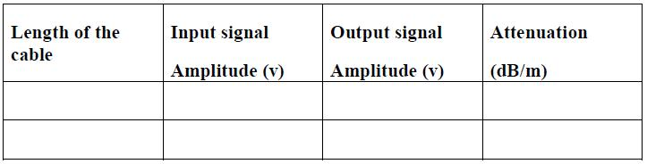

- Observe the detector signal at the port and out on oscilloscope.

- Measure the peak value of received signal at analog out terminal let this value be v2

- Now replace 1m by 3m fibre between same LED and detector.

- do not disturb any settings again take part peak voltage and let it be v

8. If α is the alternative of the fibre then.

( db/ meter ) = 10/L1 – L2 LOG V2/ V1

Where L1 – 3m fibre length for v1

L2 = 1m fibre length for v2.

This is α for peak wavelength of 660 nm.

RESULT:
Thus attenuation is calculated for the given fiber

